**Report 4th session**

In this seance we receive the car chassis. So the first thing that we did it’s check if the engine brushless was compatible whith the car chassis, but unfortunately no, we couldn’t fix it on the right way. So we choose another engine (4.5V to 15V) compatible with the car chassis and we fixed the problem. However, this engine has some drawbacks because he takes up more space, and he was heavier.

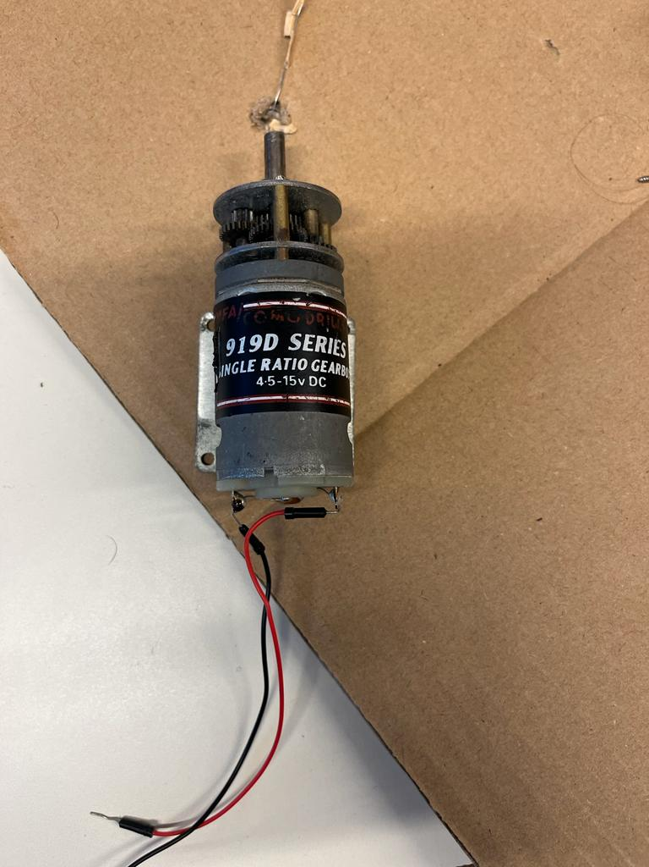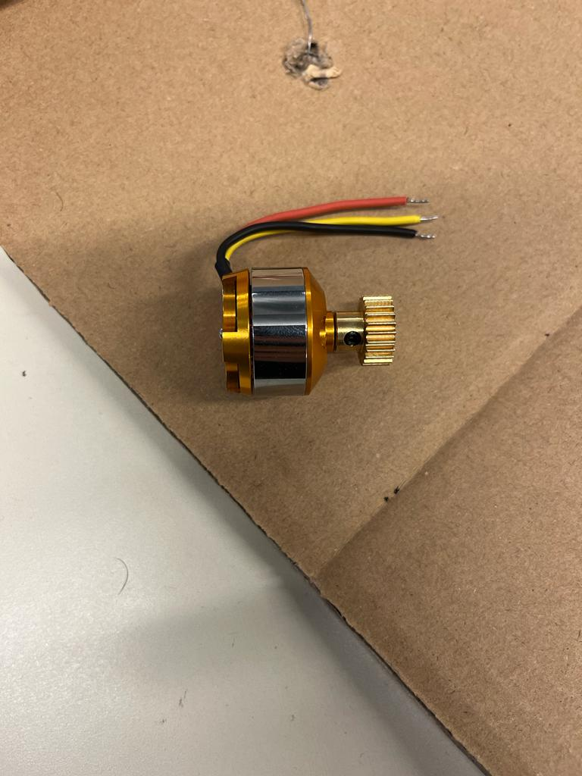

Brushless engine Single Ratio Gearbox engine

So now after we receive almost all composants we can start to compose them. And we will procred to try them one by one, to check if the code Arduino of each composant works, and then we will compose all the code.

The next session we’re goint to make the Servo Motor and the motor work, and try them on the car.